**Spatial Data Bases**

1. **Create tables for layers**

create table FIELD (

F_ID number primary key,

geometry mdsys.sdo_geometry,

F_NAME varchar(30));

create table BUILDINGS (

B_ID number primary key,

geometry mdsys.sdo_geometry,

B_NAME varchar(30));

create table TREES (

T_ID number primary key,

geometry mdsys.sdo_geometry,

T_NAME varchar(30));

create table POOL (

P_ID number primary key,

geometry mdsys.sdo_geometry,

P_NAME varchar(30));

create table ROADS (

R_ID number primary key,

geometry mdsys.sdo_geometry,

R_NAME varchar(30));

1. **Create tables for attributes of each layer**

create table BUILDING_FLOORS (

BUILD_ID number not null constraint FK_BUILD_FLOORS references BUILDINGS (B_ID) on delete cascade,

FLOOR_NUM number not null,

constraint PK_FLOORS primary key (BUILD_ID, FLOOR_NUM));

create table POOL_TYPE (

TYPE_ID number not null constraint TY_ID references POOL (P_ID) on delete cascade,

TYPE_NAME varchar(30),

constraint POOL_TYPE primary key (TYPE_ID, TYPE_NAME));

create table TREE_AGE (

TREE_ID number not null constraint TR_ID references TREES (T_ID) on delete cascade,

TREE_AGE number not null,

constraint TREE_A primary key (TREE_ID, TREE_AGE));

create table road_type (

ROAD_ID number not null constraint ROADT_ID references ROADS (R_ID) on delete cascade,

ROAD_TYPE varchar(30),

constraint ROAD_T primary key (ROAD_ID, ROAD_TYPE));

1. **Insert geometrical data**

insert into TREES values (1, MDSYS.SDO_GEOMETRY(2003, NULL, NULL,

MDSYS.SDO_ELEM_INFO_ARRAY(1,3,4),

MDSYS.SDO_ORDINATE_ARRAY(22,5,20,3,22,1)), 'TREE1');

insert into TREES values (2, MDSYS.SDO_GEOMETRY(2003,NULL,NULL,

MDSYS.SDO_ELEM_INFO_ARRAY(1,3,4),

MDSYS.SDO_ORDINATE_ARRAY(18,3,17,2,18,1)), 'TREE2');

insert into TREES values (3, MDSYS.SDO_GEOMETRY(2003,NULL,NULL,

MDSYS.SDO_ELEM_INFO_ARRAY(1,3,4),

MDSYS.SDO_ORDINATE_ARRAY(15,3,14,2,15,1)), 'TREE3');

insert into BUILDINGS values (1, mdsys.sdo_geometry(2003, null, null,

mdsys.sdo_elem_info_array(1,3,1),

mdsys.sdo_ordinate_array(1,20, 1,10, 16,10, 16,20, 1,20)), 'livinghouse');

insert into BUILDINGS values (2, mdsys.sdo_geometry(2003, null, null,

mdsys.sdo_elem_info_array(1,3,1),

mdsys.sdo_ordinate_array(1,8, 1,1, 6,1, 6,8, 1,8)), 'garage');

insert into POOL values (1, mdsys.sdo_geometry(2003, null, null,

mdsys.sdo_elem_info_array(1,3,1),

mdsys.sdo_ordinate_array(20,20, 20,13, 24,13, 24,20, 20,20)), 'swimming pool');

insert into FIELD values (1, mdsys.sdo_geometry(2003, null, null,

mdsys.sdo_elem_info_array(1,3,1),

mdsys.sdo_ordinate_array(0,20, 0,0, 25,0, 25,20, 0,20)), 'garden');

insert into ROADS values (1, mdsys.sdo_geometry(2003, null, null,

mdsys.sdo_elem_info_array(1,3,1),

mdsys.sdo_ordinate_array(10,10, 10,6, 6,6, 6,4, 12,4, 12,10, 10,10)),

'road1');

1. **Insert attributive data**

insert into TREE_AGE(TREE_ID, TREE_AGE) values (1, 5);

insert into TREE_AGE(TREE_ID, TREE_AGE) values (2, 6);

insert into TREE_AGE(TREE_ID, TREE_AGE) values (3, 10);

insert into POOL_TYPE(TYPE_ID, TYPE_NAME) values (1, 'peldbaseins');

insert into BUILDING_FLOORS(BUILD_ID, FLOOR_NUM) values (1, 1);

insert into BUILDING_FLOORS(BUILD_ID, FLOOR_NUM) values (2, 1);

insert into ROAD_TYPE(ROAD_ID, ROAD_TYPE) values (1, 'taciņa');

1. **Insert metadata**

begin

INSERT INTO USER_SDO_GEOM_METADATA(TABLE_NAME, COLUMN_NAME, DIMINFO, SRID)

VALUES ('FIELD', 'GEOMETRY', MDSYS.SDO_DIM_ARRAY(

MDSYS.SDO_DIM_ELEMENT('X', 0, 25, 1),

MDSYS.SDO_DIM_ELEMENT('Y', 0, 20, 1)), NULL);

INSERT INTO USER_SDO_GEOM_METADATA(TABLE_NAME, COLUMN_NAME, DIMINFO, SRID)

VALUES ('BUILDINGS', 'GEOMETRY', MDSYS.SDO_DIM_ARRAY(

MDSYS.SDO_DIM_ELEMENT('X', 1, 16, 1),

MDSYS.SDO_DIM_ELEMENT('Y', 1, 20, 1)), NULL);

insert into user_sdo_geom_metadata(table_name, column_name, diminfo, srid)

values ('TREES', 'GEOMETRY', mdsys.sdo_dim_array(

MDSYS.SDO_DIM_ELEMENT('X', 14, 24, 1),

MDSYS.SDO_DIM_ELEMENT('Y', 1, 5, 1)), NULL);

INSERT INTO USER_SDO_GEOM_METADATA(TABLE_NAME, COLUMN_NAME, DIMINFO, SRID)

VALUES ('ROADS', 'GEOMETRY', MDSYS.SDO_DIM_ARRAY(

MDSYS.SDO_DIM_ELEMENT('X', 6, 12, 1),

MDSYS.SDO_DIM_ELEMENT('Y', 4, 10, 1)), NULL);

INSERT INTO USER_SDO_GEOM_METADATA(TABLE_NAME, COLUMN_NAME, DIMINFO, SRID)

VALUES ('POOL', 'GEOMETRY', MDSYS.SDO_DIM_ARRAY(

MDSYS.SDO_DIM_ELEMENT('X', 20, 24, 1),

MDSYS.SDO_DIM_ELEMENT('Y', 13, 20, 1)), NULL);

end;

1. **Create indexes**

**(Created by using GeoRaptor instead of using CREATE INDEX command, e.g.:**

**CREATE INDEX trees_spix ON TREES(geometry)**

**INDEXTYPE IS MDSYS.SPATIAL_INDEX;)**

CREATE INDEX "DB_112RDM002"."TREES_GEOMETRY_SPIX" ON "DB_112RDM002"."TREES"

("GEOMETRY")

INDEXTYPE IS "MDSYS"."SPATIAL_INDEX" PARAMETERS

('sdo_indx_dims=2');

CREATE INDEX "DB_112RDM002"."BUILDINGS_GEOMETRY_SPIX" ON "DB_112RDM002"."BUILDINGS"

("GEOMETRY")

INDEXTYPE IS "MDSYS"."SPATIAL_INDEX" PARAMETERS

('sdo_indx_dims=2');

CREATE INDEX "DB_112RDM002"."FIELD_GEOMETRY_SPIX" ON "DB_112RDM002"."FIELD"

("GEOMETRY")

INDEXTYPE IS "MDSYS"."SPATIAL_INDEX" PARAMETERS

('sdo_indx_dims=2');

CREATE INDEX "DB_112RDM002"."POOL_GEOMETRY_SPIX" ON "DB_112RDM002"."POOL"

("GEOMETRY")

INDEXTYPE IS "MDSYS"."SPATIAL_INDEX" PARAMETERS

('sdo_indx_dims=2');

CREATE INDEX "DB_112RDM002"."ROADS_GEOMETRY_SPIX" ON "DB_112RDM002"."ROADS"

("GEOMETRY")

INDEXTYPE IS "MDSYS"."SPATIAL_INDEX" PARAMETERS

('sdo_indx_dims=2');

* **View created indexes metadata**

select index_name, table_name, column_name, sdo_index_type

from all_sdo_index_info;

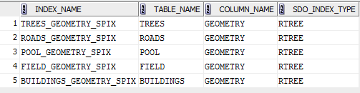

1. **Visualize data (using GeoRaptor 3.0)**

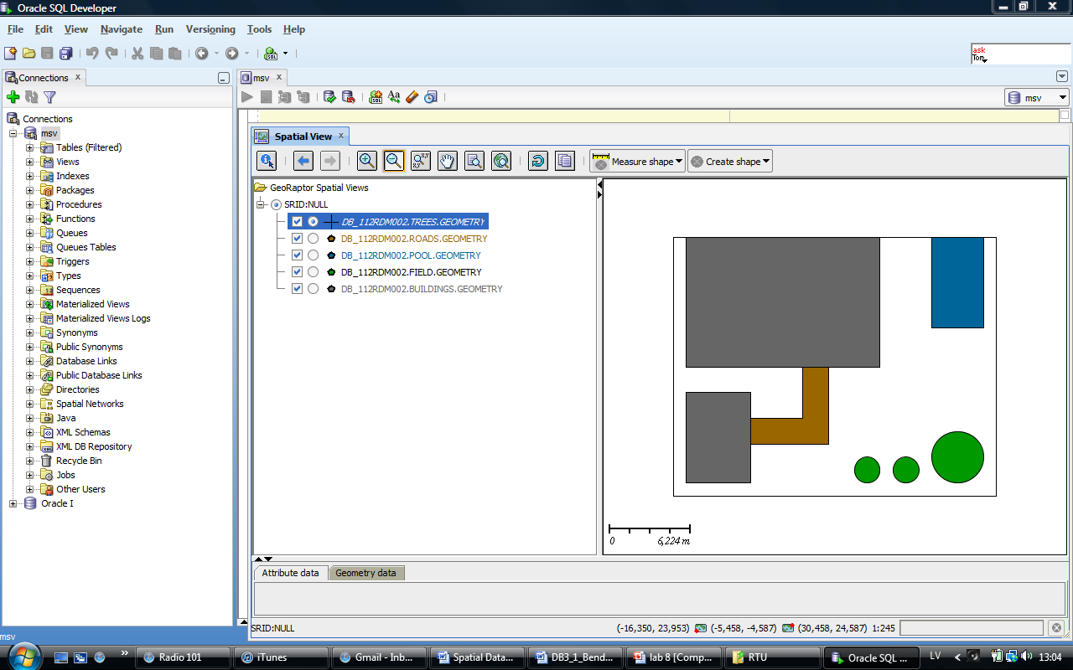

1. **Queries**
   * **1 query with SDO_FILTER**

SELECT b_name, b_id FROM BUILDINGS b, ROADS r WHERE b.b_name = 'garage' AND SDO_FILTER(b.GEOMETRY, r.GEOMETRY) = 'TRUE';



* + **2 queries working with distance**
    - **finding the closest neighbors**

SELECT p.p_name, b.b_name, mdsys.sdo_nn_distance(1) as attālums FROM POOL p, BUILDINGS b

WHERE p.p_id = 1 and b.b_name in ('garage', 'livinghouse')

and mdsys.sdo_nn(b.geometry, p.geometry, 'sdo_num_res=2',1) = 'TRUE';

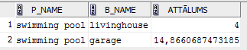

SELECT r.r_name, t.t_name, mdsys.sdo_nn_distance(1) as attālums

from ROADS r, TREES t

where r.r_id = 1 and t.t_name in ('TREE1', 'TREE2')

and mdsys.sdo_nn(t.geometry, r.geometry, 'sdo_num_res=2',1) = 'TRUE';



* + - **finding objects within distance**

SELECT b.b_name, r.r_name FROM BUILDINGS b, ROADS r

WHERE MDSYS.SDO_WITHIN_DISTANCE(b.GEOMETRY, r.GEOMETRY, 'distance = 10') = 'TRUE';

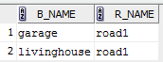

* + - **finding distance to the objects that are within the distance**

select b.b_name, r.r_name, sdo_geom.sdo_distance(r.geometry, b.geometry, 1) as distance

from ROADS r, BUILDINGS b

where b.b_id = 1 and mdsys.sdo_within_distance(b.geometry, r.geometry, 'distance=10') = 'TRUE';



* + **2 queries finding objects with certain type of interactions**

SELECT b.b_name AS māja, r.r_name AS ceļš FROM buildings b, roads r

WHERE SDO_RELATE(b.geometry, r.geometry, 'mask=anyinteract')='TRUE'

ORDER BY b.b_name;

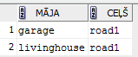

select b.b_name

from buildings b, field f

where mdsys.sdo_touch(b.geometry, f.geometry) = 'TRUE';

